
FUNDING PROPOSAL
Nurse-led, AI-assisted primary healthcare delivered to the home
Seed funding request: R9.7 million
Johannesburg launch · 18-month plan · Gauteng, then national
Prepared by Gilbert Makinana
Founder, MyThuso | Director, Akhanya IT Innovations (Pty) Ltd
gilbert@akhanya.co.za · +27 79 077 1591
September 2026 · Confidential

Contents
Contents 2
1. Executive summary 4
The ask 4
Why now 4
2. The problem 4
3. The solution 5
Brand positioning 5
4. Platform architecture 5
5. Services and value-adds by phase 6
Layer 1 — Visits (pay-as-you-go) 6
Layer 2 — Subscriptions (recurring) 7
Layer 3 — Network and B2B 7
6. Thuso AI — tests captured at home, reviewed by doctors 8
Build, partner or buy 9
Regulatory approach 9
7. Devices — Thuso Kit 10
Standard nurse kit (per nurse) 10
Shared area kit (one per launch zone) 10
8. Thuso Devices — our own connected hardware 11
Shared technology platform 11
Thuso Pod — the multi-check handheld 11
Thuso Band — the patient wearable 12
Thuso Home — the household health station 12
Thuso Lab — the portable analyser 12
Roadmap and cost 13
What the hardware unlocks 13
9. Sample testing and wearables — urine, stool, mouth, blood 13
What each sample gives us 14
Consumable and analyser costs 14
Wearables 15
10. Thuso Screen — pre-screening programmes 15
Cancer screening 15
Other pre-screening 16
Screening packages 16
Screening devices and tests (additional to the kits above) 17
11. Business model 17
Revenue streams 17
Indicative trajectory 18
12. Market 18
13. Go-to-market and take-off plan 18
First 90 days 18
Eighteen-month roadmap 19
Demand engine 19
14. Clinical governance and regulation 19
15. Use of funds, milestones and financial plan 20
Seed round: R9.7 million over 18 months 20
Milestones that gate spending 20
Return and exit thinking 21
16. Impact 21
17. Team 21
18. Risks and mitigations 21
19. Brand identity 22
20. Immediate next steps 22

1. Executive summary
MyThuso ("Thuso" means help in Setswana and Sesotho — my help, my health, at home) is an on-demand primary-healthcare platform for South Africa. A SANC-registered nurse arrives at the patient's home in under an hour, carrying a connected diagnostic kit. Vital signs, ECG, blood glucose, wound images, eye images and rapid tests are captured digitally, screened by AI, and reviewed and signed off by a doctor on a telehealth panel. The result is clinic-grade care in the living room, from R249, for the 85% of South Africans without medical aid and the insured households who want convenience.
MyThuso is a marketplace, not a clinic. Nurses are independent partners who keep 75% of visit fees and gain flexible income; patients get fast, fixed-price, verified care; doctors review cases remotely; pharmacies and laboratories fulfil orders through the platform. MyThuso earns on every visit, subscription, script, test, device, policy and corporate contract.
"Help. Health. Home." — a nurse at your door, a doctor on the screen, your record in your pocket.

The ask
We are raising R9.7 million in seed funding to launch in Johannesburg, build the AI-assisted diagnostic layer, design and pilot our own 5G-connected devices, equip 150 nurses with connected diagnostic and sample-testing kits, integrate wearables, and reach 300 visits per day and 6,000 subscribers within 18 months. Use of funds and milestones are set out in Section 15.

Why now
- Public clinics are overloaded: routine tasks such as injections, chronic checks and wound care consume nurse time that should go to complex care.
- Thousands of qualified nurses are unemployed or under-employed and want flexible, dignified income.
- Smartphones, cheap Bluetooth medical devices and AI screening have matured enough to move diagnostics into the home safely.
- National Health Insurance policy is pushing primary care closer to communities; a verified home-visit network with outcomes data becomes contractable infrastructure.
- South Africans have adopted on-demand behaviour (Uber, Sixty60, Mr D). Healthcare has not caught up.

2. The problem
For patients | For nurses | For the health system
4–6 hour clinic queues for a 10-minute task | Thousands unemployed or on short contracts | Clinics overloaded with routine tasks
Taxi fare plus a lost day's wages per visit | Low, fixed agency rates and no flexibility | Poor chronic-disease adherence and high readmissions
No affordable care at home for the elderly, post-operative patients or newborns | No path to grow income or skills | No home-visit data for planning or NHI
Private home nursing costs R600–R1,200 per visit | Isolation and no clinical support network | Late diagnosis of hypertension, diabetes, TB, HIV

The gap is a high-volume, low-ticket, township-and-suburb service with Uber pricing, Uber speed and hospital-grade governance. Existing home-nursing agencies serve the medical-aid market at premium prices; MyThuso serves everyone.

3. The solution
MyThuso combines four things nobody has put together for the mass market in South Africa:
- A dispatch marketplace — nearest suitable nurse, live ETA, fixed price, OTP-confirmed completion, cash or card.
- A connected diagnostic kit — every nurse carries Bluetooth devices that push readings straight into the patient record.
- AI screening with doctor sign-off — algorithms flag risk; a registered doctor reviews, diagnoses and prescribes remotely. The nurse is the hands, the AI is the filter, the doctor is the decision.
- A patient-owned Health Passport — a portable digital record that grows with every visit and unlocks subscriptions, insurers, employers and government programmes.

Brand positioning
MyThuso is warm, community-rooted and safe. It is not a frail-care agency, not a hospital staffing firm and not concierge medicine. Its promise: Verified nurse · Under an hour · Fixed price · Doctor-reviewed · Insured · Your record, your phone.

4. Platform architecture
Module | What it does | Phase
Thuso Nurse | On-demand nurse visits: injections, family planning, vitals and chronic checks, wound care, blood draws, post-op, mother and baby, elderly care, sick-note visits | 1
Thuso Doctor | Telehealth GP panel: reviews AI-flagged results, diagnoses, prescribes, issues certificates; live video inside the visit when needed | 1
Thuso Kit | Connected diagnostic devices carried by every nurse; readings sync to the record | 1
Thuso Devices | Own 5G-connected hardware: Thuso Pod multi-check handheld, Thuso Band wearable, Thuso Home station, Thuso Lab analyser | 3–4
Thuso AI | Screening and decision-support algorithms across vitals, ECG, images, audio and rapid tests; every output reviewed by a doctor | 1–3
Thuso Pass | Patient-owned digital Health Passport with emergency QR card | 2
Thuso Screen | Doctor-reviewed cancer and chronic-disease pre-screening packages for women, men, seniors, families, workers and communities | 2–3
Thuso Wear | Wearable sync via Apple Health and Google Health Connect; continuous vitals feeding Thuso AI between visits | 2
Thuso Pharmacy | Partner pharmacies fulfil e-scripts and adherence packs; own courier licence in year 2 | 2
Thuso Labs | Home sample collection with partner laboratories; results into the Passport | 2
Thuso Routine | Subscriptions: Chronic Routine, Family Planning, Mom, Senior (Gogo), Recover | 2–3
Thuso Family | One account for the household; book and pay for parents and children anywhere in SA; diaspora sponsorship | 2
Thuso Wallet | Prepaid credits for families, employers, stokvels and churches; vouchers sold in retail and spaza channels | 2
Thuso SOS | Urgent visit under 45 minutes with a doctor on video; panic button for the elderly with ambulance-partner escalation | 2–4
Thuso Corner | Nurse stationed at taxi ranks, spaza shops, churches and estates on fixed days for walk-up screening | 2
Thuso Work | Employer wellness, vaccination drives, chronic support, verified sick notes and sick-note verification API | 3
Thuso Locum | Marketplace for hospitals, clinics and care homes to book vetted nurses for shifts | 2
Thuso Academy | CPD courses, device and AI training, upskilling for Enrolled Nurses and carers | 3
Thuso Money | Weekly payouts, savings pockets, salary advance, equipment finance for nurses (fintech partner) | 3
Thuso Cover | Insurer-backed nurse plan with funeral cover; commission per policy | 4
Control Tower | Live operations map, dispatch, vetting pipeline, incident queue, doctor review queue, quality and revenue | 1

5. Services and value-adds by phase

Layer 1 — Visits (pay-as-you-go)
Service | Price | Nurse share | Phase
Injection / vaccination (on script) | R249 | R187 | 1
Family planning injection | R249 | R187 | 1
Vitals + chronic check (BP, glucose, SpO2, weight, adherence) | R249 | R187 | 1
Wound care / dressing change | R299 | R224 | 1
Blood draw (partner lab) | R299 | R224 | 1
Mother and baby check | R349 | R262 | 1
Post-operative check | R349 | R262 | 1
Elderly care visit (1 hour) | R399 | R299 | 1
Sick-note visit (medical certificate, doctor-reviewed) | R249 | R187 | 1
AI-assisted screening bundle (ECG + vitals + urine + doctor review) | R449 | R300 | 2
Thuso SOS urgent visit (under 45 min, doctor on video) | visit + R99 | premium split 50/50 | 2
Men's health check | R299 | R224 | 2
Mental-health check-in + tele-counsellor | R349 | R262 | 3
Allied health (physio, dietitian, OT, social worker) | R450–R800 | 75% | 3
Home carer (non-nurse, RN-supervised) | R120–R180/hr | 75% | 3
Palliative care (hospice partner) | package | partner split | 4

Layer 2 — Subscriptions (recurring)
Product | Price | Includes | Phase
Chronic Routine | R199/month | Monthly visit, AI-screened vitals, doctor review, script collection, medicine delivery, adherence nudges | 2
Family Planning Plan | R99/month | Injection every 2–3 months, reminders, discreet booking | 2
Thuso Mom | R249/month | Antenatal visits, immunisation schedule, home visits for baby's first year | 3
Thuso Senior (Gogo) | R699/month | Weekly elderly visit, medication management, fall-risk check, family report | 3
Thuso Recover | per package | Post-discharge visits for 2–6 weeks; sold to patients and hospitals | 3
Thuso Alert | R79/month | Panic button dispatching nearest nurse and ambulance partner | 4
Thuso Cover | R99–R199/month | Insurer-backed visit allowance plus funeral cover | 4

Layer 3 — Network and B2B
Product | Buyer | Revenue | Phase
Pharmacy fulfilment and adherence packs | patients | 8–15% of script value | 2
Laboratory tests | patients, insurers | R50–R150 per test | 2
Devices sold or rented to homes (BP monitor, glucometer, oximeter) | patients | margin + rental | 3
Nurse locum marketplace | hospitals, clinics, care homes | 15–20% of shift value | 2
Employer wellness and vaccination drives | employers | R120–R250 per employee per event | 3
Sick-note verification API | employers | per check / licence | 3
Hospital discharge programme | hospital groups | per patient | 3
School health screening | schools | per learner per year | 3
Event medics | organisers | per event | 3
Estate and retirement-village concierge nurse | body corporates | monthly retainer | 3
Sponsored community screenings | pharma, FMCG | campaign fees | 3
Insurer services: remote monitoring, claims verification, low-cost plan wellness | insurers, schemes | per member / per visit | 4
Government and donor programmes: HIV/TB adherence, maternal health, chronic care | DoH, NGOs, donors | contracted service + dashboards | 4
Stokvel, church and corporate wallets | groups, employers | prepaid revenue | 3
Anonymised population-health insights | insurers, government, research | licence (POPIA-first) | 4

6. Thuso AI — tests captured at home, reviewed by doctors
This is the layer that turns a nurse visit into a clinical encounter. Each test below is captured by the nurse with a connected or smartphone-based device, screened by an algorithm, and placed in a doctor review queue. The doctor confirms, orders further tests, prescribes or refers. Nothing is diagnosed by AI alone; AI is clinical decision support and the doctor remains accountable, in line with HPCSA telemedicine guidance. Turnaround target: urgent flags in 15 minutes, routine reviews within 4 hours.
Test | Device / capture | What the AI does | Doctor decides | Phase
Vital-sign risk score | BP cuff, oximeter, thermometer, scale (Bluetooth) | Early-warning score; trend versus patient baseline; flags hypertensive urgency, hypoxia, fever | Treat, refer, adjust chronic meds | 1
Blood glucose and HbA1c | Connected glucometer; point-of-care HbA1c analyser (area kit) | Diabetes control classification and hypo/hyper alerts | Medication changes, dietitian referral | 1
Single-lead ECG | Handheld ECG pad (30-second trace) | Detects atrial fibrillation, bradycardia, tachycardia; quality check | Cardiology referral, anticoagulation review | 2
Wound imaging | Smartphone camera with reference sticker | Measures area and depth trend, detects infection signs, tracks healing week on week | Antibiotics, debridement referral | 2
Skin lesion and rash triage | Smartphone dermatoscope attachment | Prioritises lesions for review; flags suspicious patterns | Dermatology referral, biopsy | 2
Urine dipstick reading | Standard strips read by smartphone camera | Reads 10 parameters objectively; flags infection, protein, glucose, pregnancy | Antibiotics, antenatal action, kidney follow-up | 2
Rapid test reading (HIV, pregnancy, malaria, syphilis, COVID/flu) | Photo of the test cassette | Reads faint lines consistently; timestamps and stores result | Confirmatory testing, treatment initiation, counselling | 2
Anaemia screening | Smartphone photo of eyelid / nail bed, or non-invasive haemoglobin device | Estimates haemoglobin; flags likely anaemia | Full blood count, iron therapy | 2
Cough and lung sound analysis | Digital stethoscope; phone microphone cough recording | Screens for TB-suggestive cough patterns, wheeze, crackles, pneumonia risk | Sputum test, chest X-ray, TB treatment | 3
Diabetic eye screening | Handheld fundus camera (area kit) | Detects diabetic retinopathy and grades severity | Ophthalmology referral, laser treatment | 3
Foot ulcer risk | Camera + monofilament checklist | Predicts ulcer risk in diabetics | Podiatry, footwear, wound plan | 3
Antenatal ultrasound | Handheld ultrasound probe with AI guidance (area kit) | Guides nurse to standard views; estimates gestational age, fetal position, heart rate | High-risk pregnancy referral | 3
Child growth and malnutrition | Scale, height mat, MUAC tape | Plots WHO growth curves; flags stunting and wasting | Nutrition programme, paediatric referral | 3
Medication adherence prediction | Visit history, refill data, self-report | Predicts who will default on HIV, TB or chronic treatment | Adherence counselling, community support | 3
Symptom triage assistant | Patient chat in app or WhatsApp | Structured history in local languages; suggests which service to book | Nurse or doctor confirms | 2

Build, partner or buy
- Phase 1: buy certified devices and licence proven AI models (ECG, retinopathy, dermatology, urine strips, rapid-test readers) from established vendors. Speed and regulatory cover matter more than owning the model on day one.
- Phase 2: build MyThuso's own models where we hold unique data — vital-sign risk scoring for our population, wound-healing trajectory, adherence prediction and the multilingual triage assistant.
- All AI outputs are logged with the doctor's decision, creating a labelled dataset that improves the models and becomes a defensible asset.

Regulatory approach
- AI is deployed as clinical decision support with a registered doctor accountable for every diagnosis, prescription and certificate.
- Devices must be SAHPRA-registered or exempt; software with a diagnostic claim is treated as a medical device and registered accordingly.
- Telehealth follows HPCSA guidelines; nurses act within SANC scope of practice; pharmacies dispense under the Medicines Act; health data is handled as special personal information under POPIA with SA hosting and explicit consent.
- A Clinical Governance Lead (senior nurse) and a Medical Director (doctor) own protocols, incident management and regulator relationships.

7. Devices — Thuso Kit
Every nurse carries a standard connected kit. Higher-cost devices are held as shared "area kits" allocated per zone and booked through the nurse app. In Phase 3 we design our own compact device to reduce cost per kit and lock in the workflow.

Standard nurse kit (per nurse)
Device | Purpose | Indicative cost
Bluetooth upper-arm BP monitor | Hypertension screening and monitoring | R900
Connected glucometer + strips | Diabetes screening and monitoring | R500
Fingertip pulse oximeter (Bluetooth) | Oxygen saturation and pulse | R400
Infrared thermometer | Temperature | R300
Bluetooth scale and height mat, MUAC tape | Weight, BMI, child growth | R600
Handheld single-lead ECG pad | Arrhythmia screening | R2,500
Smartphone dermatoscope clip | Skin and wound imaging | R700
Urine strips, rapid test cassettes (HIV oral and blood, syphilis, pregnancy, malaria, strep, FIT), lancets, sharps container, PPE | Consumables (monthly float) | R800
Peak-flow meter and MUAC tape | Asthma/COPD and child nutrition | R300
Branded bag, ID badge, phone mount, power bank, wound reference stickers | Kit and identity | R1,000
Total per nurse |  | ≈ R8,000

Shared area kit (one per launch zone)
Device | Purpose | Indicative cost
Digital stethoscope with recording | Lung and heart sound analysis, TB screening | R6,000
Point-of-care HbA1c / lipid analyser | Diabetes control and cholesterol on the spot | R25,000
Handheld non-mydriatic fundus camera | Diabetic retinopathy screening | R45,000
Handheld ultrasound probe | Antenatal and basic abdominal scans | R55,000
Non-invasive haemoglobin meter | Anaemia screening | R8,000
Creatinine meter | Kidney function on the spot | R6,000
Pocket urine analyser | Objective 10-parameter strip reading | R6,000
Bluetooth spirometer | Asthma and COPD lung function | R3,500
Total per zone |  | ≈ R160,000

These bought devices get MyThuso to market fast. Section 8 sets out the custom hardware that replaces them from Phase 3.

8. Thuso Devices — our own connected hardware
Off-the-shelf devices are a bag of separate gadgets with separate batteries, apps and calibrations. From Phase 3 MyThuso replaces them with four purpose-built devices designed around the nurse's workflow and the patient's home, built with a South African electronics partner and certified through SAHPRA. Owning the hardware cuts the cost per nurse kit by more than half, locks the workflow to the MyThuso platform and creates a device business in its own right.

Shared technology platform
- 5G / LTE-M eSIM in every device: results upload the moment they are captured, video consults run from the device, and nothing depends on the nurse's phone or the patient's airtime. Automatic fallback to LTE and offline store-and-forward for weak-signal areas.
- Edge AI processor: ECG, image and sound screening run on the device in under a second, so results are available without connectivity and only structured data leaves the home.
- NFC tap-in: the patient's Thuso card or Band identifies them; the nurse logs in by fingerprint. No typing, no wrong-patient errors.
- Secure element and end-to-end encryption; over-the-air updates; remote lock and wipe if a device is lost.
- Load-shedding ready: long-life batteries, USB-C fast charge and solar on the home unit.
- Voice guidance in 11 official languages for nurses and patients; screen-reader accessible.
- Common cartridge and strip format across devices; one supply chain, one calibration standard.

Thuso Pod — the multi-check handheld
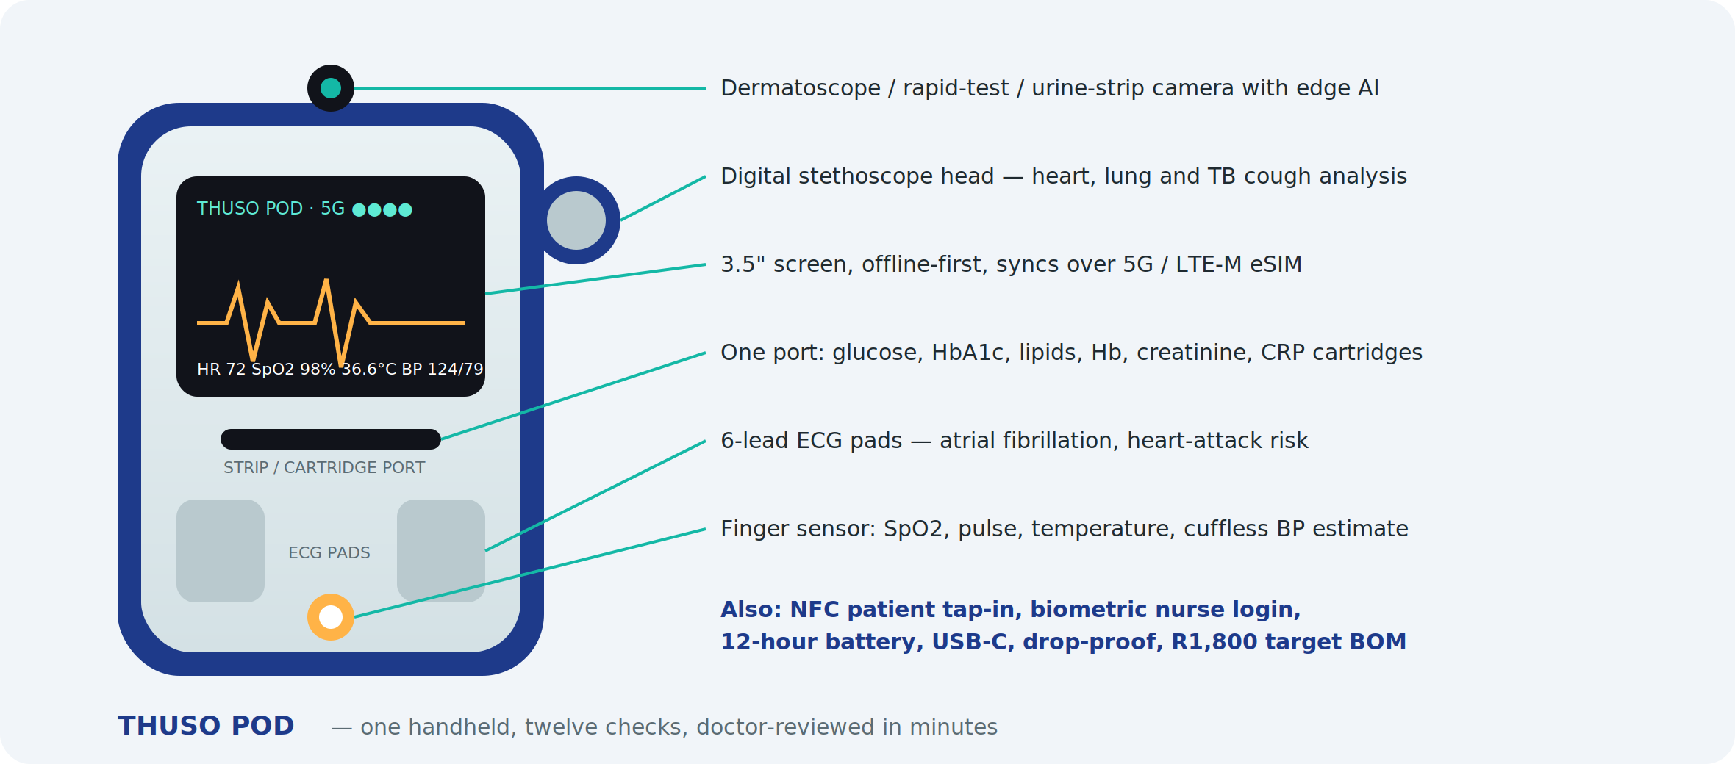
One rugged handheld that performs twelve checks in a single visit: blood pressure (finger-sensor estimate, with an optional Bluetooth cuff for confirmation), SpO2, pulse, temperature, 6-lead ECG, heart and lung sounds, cough analysis, blood cartridges for glucose, HbA1c, lipids, haemoglobin, creatinine and CRP, urine-strip reading, rapid-test cassette reading and dermatoscope imaging. Edge AI flags risk on the spot; the result set reaches the doctor queue over 5G before the nurse leaves. Target bill of materials R1,800 at 1,000 units against roughly R8,000 for the equivalent bought kit.

Thuso Band — the patient wearable
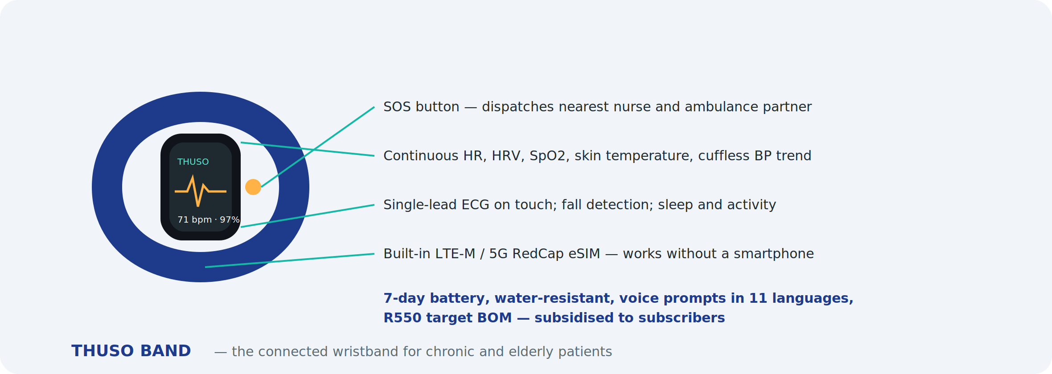
A low-cost wristband for Chronic Routine, Senior and post-discharge patients. Continuous heart rate, HRV, SpO2, skin temperature, cuffless blood-pressure trend, single-lead ECG on touch, sleep, activity and fall detection, with an SOS button that dispatches the nearest nurse and the ambulance partner. A built-in LTE-M / 5G RedCap eSIM means it works for a grandmother with no smartphone. Seven-day battery, water-resistant, voice prompts. Target BOM R550; subsidised to subscribers and sold to employers and insurers.

Thuso Home — the household health station
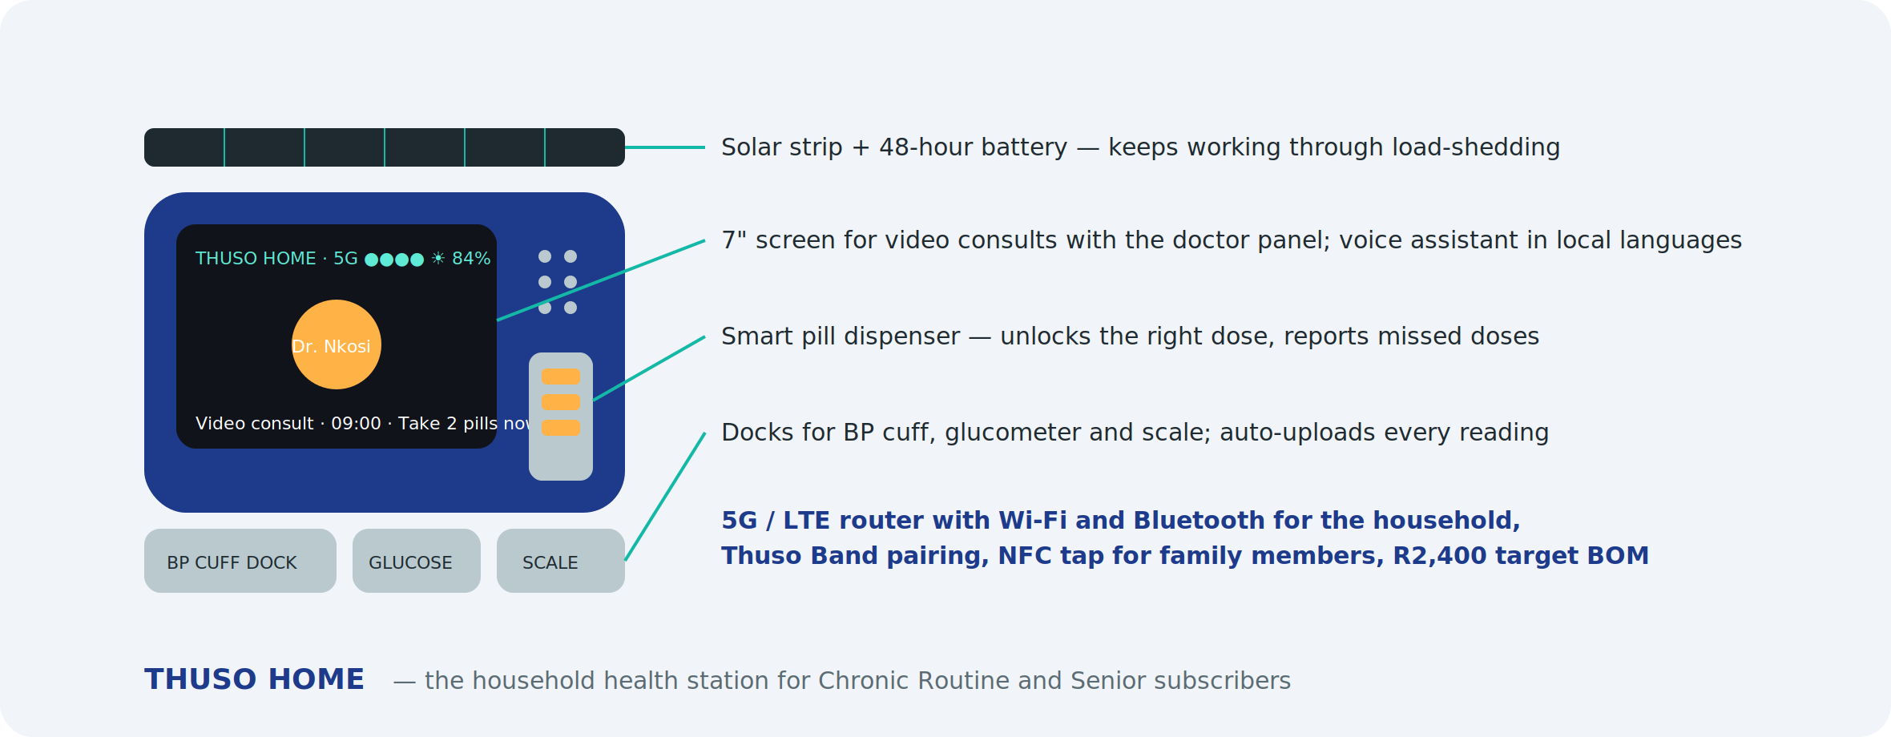
A countertop station for households on subscription: a 7-inch screen for video consultations with the doctor panel, a voice assistant in local languages, a smart pill dispenser that unlocks the right dose at the right time and reports missed doses, docks for the blood-pressure cuff, glucometer and scale that upload every reading automatically, and a 5G router that gives the household Wi-Fi and pairs Thuso Bands. A solar strip and 48-hour battery keep it running through load-shedding. Target BOM R2,400; rented at R99/month inside Chronic Routine and Senior plans.

Thuso Lab — the portable analyser
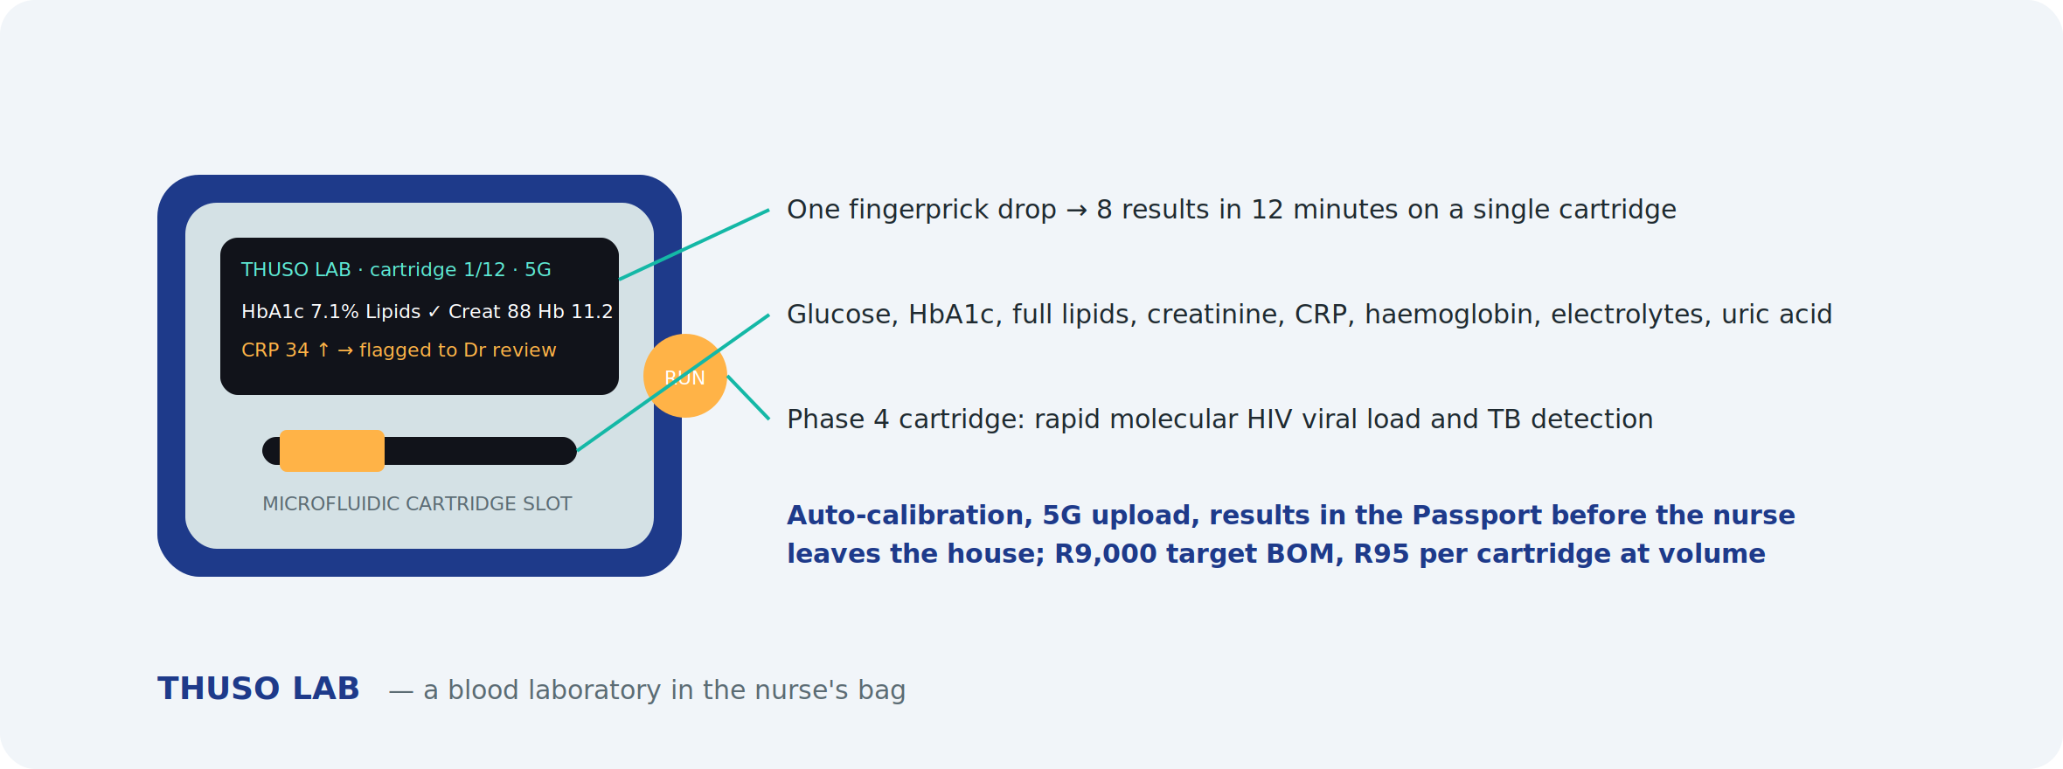
A microfluidic analyser that turns one fingerprick drop into eight results in twelve minutes on a single cartridge: glucose, HbA1c, full lipids, creatinine, CRP, haemoglobin, electrolytes and uric acid. Self-calibrating, 5G-connected, results straight into the Health Passport. A Phase 4 molecular cartridge targets rapid HIV viral load and TB detection at the bedside. Target BOM R9,000; R95 per cartridge at volume against R150–R250 for bought equivalents.

Roadmap and cost
Device | Design and prototype | Certification (SAHPRA, ICASA) | Pilot run (200 units) | Total to pilot
Thuso Pod | R550,000 | R180,000 | R360,000 | R1,090,000
Thuso Band | R220,000 | R90,000 | R110,000 | R420,000
Thuso Home | R180,000 | R60,000 | R100,000 | R340,000
Thuso Lab (Phase 4, Series A) | R900,000 | R250,000 | R450,000 | R1,600,000 (not in this round)

This round funds Pod, Band and Home to pilot (R1.85m). Thuso Lab and volume manufacturing are Series A items. Design partner selection, industrial design and firmware start in month 10; SAHPRA submission in month 15; pilot units in nurses' hands by month 18.

What the hardware unlocks
- Kit cost per nurse falls from about R8,000 to under R3,500, so scaling to 5,000 nurses becomes affordable.
- Device rental and cartridge sales become a recurring revenue line independent of visits.
- Insurers, employers and government programmes can buy Thuso Band and Thuso Home as remote-monitoring products.
- The device and its data are MyThuso's; a competitor cannot copy the workflow by buying the same gadgets online.
- Export potential across Africa where the same connectivity and load-shedding realities apply.

9. Sample testing and wearables — urine, stool, mouth, blood
A nurse visit can capture most of what a clinic collects. Rapid tests and point-of-care analysers give results in minutes; anything needing a laboratory is collected at home and sent through Thuso Labs. Every result is stored in the Health Passport and, where it carries a diagnosis, reviewed by a doctor.

What each sample gives us
Sample | At home (minutes) | To the laboratory (Thuso Labs) | Conditions screened
Urine | 10-parameter dipstick read by phone camera or pocket analyser: glucose, protein, ketones, blood, nitrites, leukocytes, pH, specific gravity, bilirubin, urobilinogen; hCG pregnancy; microalbumin; drug screen | Culture and sensitivity, cytology, albumin-creatinine ratio | UTI, diabetes control, kidney disease, dehydration, pre-eclampsia, pregnancy, substance use
Stool | FIT (hidden blood), H. pylori antigen, rotavirus/adenovirus, calprotectin | Parasites, culture, microbiome | Colorectal cancer screening, ulcers, child diarrhoea, inflammatory bowel disease
Mouth and saliva | Oral-swab HIV, COVID/flu antigen, strep A throat swab, saliva drug test; phone photo for AI oral-cancer and dental screening | Cortisol and hormone panels, genetic tests | HIV, respiratory infection, strep throat, oral cancer, dental disease
Blood (fingerprick) | Glucose, HbA1c, lipid panel, haemoglobin, HIV/syphilis duo, hepatitis B/C, malaria, CRP, creatinine, INR; multi-analyte chemistry panel on the area analyser | — | Diabetes, cholesterol, anaemia, HIV, syphilis, hepatitis, malaria, infection, kidney function, warfarin control
Blood (venous draw) | Collected by nurse | Full blood count, kidney and liver function, thyroid, PSA, vitamin D, iron studies, CD4, viral load, tumour markers | Broad diagnostic and monitoring panels
Breath and lungs | Bluetooth spirometer, peak flow, breathalyser, cough recording | — | Asthma, COPD, TB risk, occupational alcohol screening

Consumable and analyser costs
Item | Indicative cost
Urine strips (10-parameter) | R3 per strip; pocket analyser R6,000 (optional; phone reading is free)
Microalbumin strip / hCG strip / drug-screen cup | R25 / R15 / R80
FIT / H. pylori / rotavirus / calprotectin rapid kits | R120 / R60 / R70 / R250
Oral HIV swab / COVID-flu / strep A / saliva drug test | R80 / R60 / R50 / R120
HIV-syphilis duo / hepatitis B-C / malaria / CRP rapid | R45 / R50 / R30 / R60
HbA1c analyser and cartridge | R25,000 + R60 per test
Lipid panel cartridge (same analyser) | R120 per test
Haemoglobin meter and cuvettes | R3,500 + R15 per test
Creatinine meter and strips | R6,000 + R80 per test
Multi-analyte chemistry analyser (area kit, Phase 3) | R60,000 + R150 per panel
Bluetooth spirometer / peak-flow meter / breathalyser | R3,500 / R300 / R800

Tests are priced to the patient at consumable cost plus a margin and, where relevant, the doctor review — for example a fingerprick HIV/syphilis test at R79, a FIT screening at R199 and an HbA1c at R249 inside the AI-screening bundle. Employer, insurer and government programmes buy tests in volume.

Wearables
MyThuso syncs with Apple Health (Apple Watch) and Google Health Connect (Samsung Galaxy Watch, Fitbit, Huawei, Xiaomi, Garmin, Oura). Data captured continuously between visits:
- Heart rate, heart-rate variability, resting heart rate trends
- Blood-oxygen saturation, especially overnight
- Single-lead ECG and irregular-rhythm notifications (Apple, Samsung)
- Cuff-calibrated blood-pressure trends (Samsung)
- Sleep, steps, activity and skin temperature
- Fall detection for elderly subscribers
Consumer wearables are not diagnostic devices, so Thuso AI treats them as trend data: a rising resting heart rate or falling overnight SpO2 in a Chronic Routine patient triggers a nurse visit and a doctor review rather than a diagnosis. Commercially, MyThuso subsidises a R700 band for Chronic Routine and Senior subscribers and offers employers and insurers a wearable-linked wellness tier.
Wearable option | Indicative cost | Role
Xiaomi-class smart band | R700 | Subsidised to subscribers: heart rate, SpO2, sleep, steps
Samsung Galaxy Watch | R4,500–R7,000 | ECG, BP trends, fall detection; premium subscribers and Senior plan
Apple Watch SE | from R6,500 | ECG, irregular rhythm, fall detection; iPhone users
Fitbit / Garmin | R2,500–R6,000 | Wellness tiers for employers
Health Connect and Apple Health integration | R150,000 once-off | Development, consent flows, data mapping into the Passport

10. Thuso Screen — pre-screening programmes
South Africa's biggest killers — cervical, breast, colorectal and prostate cancer, heart disease, stroke, kidney failure, TB and HIV — are caught late because almost nobody is screened. Thuso Screen turns the nurse visit into a structured, doctor-reviewed screening programme with an automatic referral pathway and a report in the Health Passport.

Cancer screening
Cancer | How we screen at home | Follow-up pathway
Cervical | HPV self-sampling swab collected by the woman, sent to the lab (WHO-recommended route; reaches women who avoid pap smears) | Positive → colposcopy referral
Breast | Clinical breast exam by nurse, handheld pressure-sensor breast scanner (no radiation, minutes), risk questionnaire | Suspicious → mammogram / ultrasound
Colorectal | FIT stool kit from age 45, earlier with family history | Positive → colonoscopy
Prostate | PSA fingerprick rapid test or lab PSA plus symptom score, from age 45 (40 with family history) | Raised → urology
Oral | Nurse visual exam and phone photo for AI lesion screening; targets smokers and snuff users | Lesion → ENT / dental biopsy
Skin | Dermatoscope photos, AI-prioritised, doctor-reviewed | Suspicious → dermatology
Lung | Symptom and exposure questionnaire, cough recording, spirometry; smokers, miners, TB survivors | High-risk → chest X-ray / CT
HIV-linked cancers | Skin and oral check for Kaposi sarcoma and lymphoma signs in HIV-positive patients | Referral

Other pre-screening
Area | Screen | Devices / tests
Cardiovascular and stroke | 10-year risk score; atrial fibrillation | BP, lipids, glucose, single-lead ECG
Kidney | Diabetic and hypertensive kidney disease | Creatinine meter, urine microalbumin
Liver | Hepatitis and alcohol-related risk | Hepatitis B/C rapid tests, AUDIT questionnaire
TB and HIV | Symptom screen, cough analysis, testing | Oral/fingerprick HIV, sputum referral
Mental health | Depression and anxiety in local languages | PHQ-9, GAD-7, tele-counsellor referral
Cognitive decline | Over-60s in the Senior plan | 5-minute cognitive screen
Osteoporosis and falls | Elderly risk and balance | Risk questionnaire, timed-up-and-go test
Vision and hearing | Acuity and audiometry | Phone acuity app, headphone audiometry; optometry and hearing-aid referrals
Child development | Growth, nutrition, milestones, immunisation gaps | Scale, MUAC, growth curves
Antenatal risk | Hypertension, anaemia, infection, gestational diabetes | BP, urine protein, haemoglobin, HIV/syphilis, glucose
Occupational health | Fitness-for-work panels for mines, factories, transport | Spirometry, audiometry, vision, drug and alcohol screens

Screening packages
Package | Includes | Price
Women's Screen | HPV self-sample, breast exam and scanner, BP, glucose, HIV, anaemia, PHQ-9 | R699
Men's Screen | PSA, FIT, BP, lipids, glucose, HIV, oral and skin check | R649
Senior Screen | Cardiovascular, kidney, cognitive, fall risk, vision, hearing, FIT | R799
Family Screen | Two adults and children: growth, immunisation, BP, glucose, HIV | R999
Worker Screen | Occupational panel per employee | R350–R550
Community Screen | Sponsored Thuso Corner day: BP, glucose, HIV, cervical and breast sign-up | sponsor-funded

Screening devices and tests (additional to the kits above)
Item | Indicative cost
HPV self-sampling kit + lab processing | R280 per test
Handheld breast scanner (area kit) | R65,000 per zone
PSA rapid test / lab PSA | R90 / R180 per test
Audiometry headphones and app licence | R2,500 per zone
Questionnaire and cognitive screen licences | included in platform

Screening is also MyThuso's strongest institutional story: insurers pay for early detection, employers pay for occupational panels, and the Department of Health and donors fund cervical, breast, TB and HIV screening at population scale. Every screen produces structured, anonymisable data on disease burden by area.

11. Business model
Unit economics on a R299 visit: patient pays R299 → nurse receives R224 → payment costs R9 → MyThuso retains about R66. Doctor review is paid per case (R35–R60) from the AI-screening bundle and subscription margin.

Revenue streams
- 25% of every visit
- Subscriptions: Chronic Routine, Family Planning, Mom, Senior, Recover, Alert
- AI-screening bundles, Thuso Screen packages and doctor reviews
- Pharmacy, laboratory, rapid-test and device commissions
- Wearable-linked wellness tiers for subscribers, employers and insurers
- Nurse locum marketplace fees
- Employer, school, estate, hospital and event contracts
- Insurance and funeral commissions
- Vouchers, prepaid wallets and group plans
- Government and donor programme contracts
- Nurse-side: Academy, Store, fintech commissions
- Anonymised data insights (year 2, POPIA-first)

Indicative trajectory
Point | Visits/day | Subscribers | Monthly revenue | Monthly costs | Net
Month 5 (launch) | 30 | – | R55k | R190k | –R135k
Month 9 | 100 | 2,000 | R360k | R280k | +R80k
Month 15 | 300 | 6,000 | R1.15m | R520k | +R630k
Month 24 (Gauteng + Cape Town) | 600 | 14,000 | R2.6m | R1.1m | +R1.5m
Year 3 (3 cities) | 1,000 | 20,000 | R4.0m | R1.6m | +R2.4m

Revenue includes retained visit margin, subscription margin after nurse and delivery costs, AI bundles, pharmacy, labs, locum and B2B. Costs include clinical and medical leadership, support, doctors' review fees, technology, insurance, marketing and device depreciation.

12. Market
- About 50 million South Africans have no medical aid and depend on public clinics; roughly 9 million have medical aid and increasingly want convenience.
- Hypertension, diabetes, HIV and TB together affect well over 15 million people who need regular monitoring and medication — the core of Chronic Routine.
- More than a million births a year and a growing elderly population drive Mom and Senior subscriptions.
- South Africa has hundreds of thousands of registered nurses; a meaningful share are unemployed, part-time or seeking extra income.
- Corporate wellness, insurers seeking low-cost plan benefits, hospitals reducing readmissions and government programmes are large institutional buyers.
Initial focus: Johannesburg zones with high density and mixed income — Soweto, Roodepoort/Randburg, Tembisa/Kempton Park — then Pretoria, Ekurhuleni, Cape Town and Durban.

13. Go-to-market and take-off plan

First 90 days
Days | Focus | Outcomes
1–30 | Company, Clinical Governance Lead, Medical Director, protocols, insurance, POPIA, pharmacy and lab partners, v1 build, nurse recruitment opens | Foundation in place; 100 nurse applications
31–60 | Vet and train 50 RNs; issue kits; doctor panel of 5; friends-and-family pilot of 100 visits; support team hired | Zero-incident pilot; pricing and menu finalised
61–90 | Public launch in three zones; first-visit offer; first Thuso Corner; referral rewards | 15–30 visits/day

Eighteen-month roadmap
Months | Milestones
1–2 | Foundation, build, recruit: 50 RNs vetted, v1 live, 5 doctors on panel
3–5 | Launch nine core services incl. family planning; 30 visits/day; 500 visits with zero unresolved incidents
6–9 | Chronic Routine and Family Planning Plan; pharmacy delivery; labs; ECG, wound, urine and rapid-test AI live; Health Passport; locum marketplace; five Thuso Corners; Play Store app; 100 visits/day, 2,000 subscribers, 150 RNs
10–12 | Thuso Mom and Senior; employer wellness; hospital discharge pilot; school health pilot; Academy; Enrolled Nurses and carers; Pretoria and Ekurhuleni; 200 visits/day, 4,000 subscribers
13–18 | Retinopathy, lung-sound and ultrasound AI with area kits; insurer partner; Thuso Pod design; Cape Town; 300+ visits/day, 6,000+ subscribers, 500 RNs

Demand engine
- Trusted nodes: pharmacies (script-linked visits), churches, stokvels, estate managers, taxi ranks, spaza shops and clinics referring overflow.
- Thuso Corners for walk-up screening and sign-up.
- Vouchers in cash channels; family and diaspora sponsorship ("book a nurse for Mom").
- Community radio, WhatsApp groups, local Facebook and referral rewards.
- B2B sales from month 6: locum, employers, hospitals, schools, estates, insurers.

14. Clinical governance and regulation
- Nurses: SANC-registered with a current annual practising certificate, verified at onboarding and annually; Registered Nurses only at launch; Enrolled Nurses and carers under RN supervision from Phase 3.
- Scope: every service mapped to SANC scope of practice; injections and medicines only on valid prescription; diagnosis and prescribing by the doctor panel.
- Doctors: HPCSA-registered, contracted to the review panel, working under HPCSA telemedicine guidelines and a Medical Director.
- Medicines: dispensing and delivery only through licensed pharmacies.
- Protocols at launch: injection administration, wound care, vitals and chronic check, phlebotomy, post-operative assessment, mother and baby check, elderly assessment, medical certificate criteria, infection control and sharps, emergency escalation and referral, device use and AI result handling.
- Vetting: SANC, ID, police clearance, references, skills assessment, practical sign-off, four hours online and one day practical training including device and AI workflow.
- Insurance: professional indemnity per nurse (group scheme), doctor indemnity, platform public liability, cyber cover.
- POPIA: health data as special personal information; explicit consent, SA hosting, encryption at rest and in transit, role-based access, audit logs, Information Officer, retention policy; patient owns and can export the Passport.
- Incident management: escalation acknowledged within 5 minutes, Clinical Lead review within 24 hours, transparent reporting.
- Regulator engagement: early meetings with SANC, HPCSA, SAHPRA, Gauteng Department of Health and DENOSA, positioned as decongesting clinics and creating nurse employment.

15. Use of funds, milestones and financial plan

Seed round: R9.7 million over 18 months
Category | Amount | Detail
Clinical and medical leadership | R1,200,000 | Clinical Governance Lead, Medical Director (part-time), nurse community manager, area supervisors
Doctor review panel | R650,000 | Per-case review fees during ramp-up before bundle revenue covers them
Technology and AI | R1,650,000 | Patient, nurse, partner and Control Tower apps; AI model licences and integration; own-model development; Apple Health and Google Health Connect wearable integration; hosting; security and POPIA
Devices and test consumables | R2,200,000 | 150 standard nurse kits (R1.2m), three shared area kits incl. breast scanners (R680k), 12-month sample and screening consumable float (R220k) and 500 subsidised wearable bands (R100k)
Thuso Devices — Pod, Band, Home to pilot | R1,850,000 | Industrial design, firmware, prototypes, SAHPRA and ICASA certification, 200-unit pilot runs with a local electronics partner
Operations and support | R700,000 | Dispatch and support team, training, kit logistics
Marketing and community activation | R650,000 | Thuso Corners, trusted-node partnerships, vouchers, radio, digital, launch offers
Regulatory, legal, insurance | R420,000 | Company setup, contracts, indemnity and liability cover, SAHPRA and POPIA compliance, attorney
Contingency | R380,000 | About 5% of the round
Total | R9,700,000

Milestones that gate spending
Milestone | Target | Releases
M1 | 50 vetted RNs online, v1 live, 5 doctors on panel | Tranche 1: R3.0m
M2 | 500 visits, zero unresolved incidents, 30 visits/day
M3 | 100 visits/day, 2,000 subscribers, AI bundle and Thuso Screen packages live | Tranche 2: R3.9m
M4 | 200 visits/day, 4,000 subscribers, first B2B contracts, Pretoria open
M5 | 300 visits/day, 6,000 subscribers, 500 RNs, Cape Town open, Thuso Pod and Band pilot units in the field | Tranche 3: R2.8m

Return and exit thinking
By month 18 MyThuso targets monthly revenue above R1.1 million with positive operating cash flow, a network of 500 nurses, a doctor panel, a proprietary labelled clinical dataset and institutional contracts. Natural Series A and strategic partners include insurers, pharmacy groups, hospital groups and health-tech investors; the platform is also positioned to contract under NHI as community primary-care infrastructure.

16. Impact
- Jobs: 500 nurse-entrepreneurs earning R4,000–R15,000 per month on their own schedule within 18 months; carers, drivers and support staff on top.
- Access: clinic-grade screening in homes and communities that currently wait hours or go without.
- Outcomes: earlier detection of cervical, breast, colorectal and prostate cancer, hypertension, diabetes, kidney disease, TB, HIV and retinopathy; better chronic adherence; fewer hospital readmissions.
- System: measurable decongestion of public clinics and a data layer for provincial and national planning.
- Inclusion: multilingual, cash-friendly, township-first; family and diaspora sponsorship keeps care flowing to those who cannot pay.

17. Team
- Gilbert Makinana — Founder and CEO. Software entrepreneur; Director of Akhanya IT Innovations, a Level 1 B-BBEE IT company delivering custom software, integration and data solutions to public and private clients. Leads product and technology.
- Clinical Governance Lead — senior Registered Nurse (10+ years, clinic management experience). To be appointed at funding.
- Medical Director — HPCSA-registered doctor, part-time, owning the doctor panel and AI governance. To be appointed at funding.
- Nurse Community Manager, dispatch and support team, B2B sales lead (month 6).
- Akhanya IT Innovations development team — builds and operates the platform.
- Advisers: healthcare attorney, SAHPRA regulatory consultant, electronics design partner, bookkeeper.

18. Risks and mitigations
Risk | Mitigation
Clinical incident | Protocols, ruthless vetting, indemnity, escalation SLA, Clinical Lead and Medical Director, transparent incident handling
AI error | AI is decision support only; doctor sign-off on every result; licensed, validated models first; continuous audit of AI-versus-doctor outcomes
Regulatory pushback | Early engagement with SANC, HPCSA, SAHPRA and DoH; RN-only launch; strict scope mapping; pharmacy-only dispensing; SAHPRA pathway for devices and software
Nurse reliability and quality | Ratings, reliability bonuses, tiers, density, referral growth, removal policy
Device loss or damage | Kits issued against deposit and tracked; insurance; area kits booked and signed for
Cash leakage | OTP completion, reconciliation against payouts, cashless incentives
Slow demand | Trusted-node acquisition, Thuso Corners, vouchers, launch offers, locum revenue as bridge
Competition | Speed to density, Health Passport, doctor-reviewed AI, nurse loyalty via tiers and Thuso Money
Data breach | SA hosting, encryption, access controls, cyber cover, Information Officer
Cash-flow strain | Milestone-gated tranches, subscriptions and prepaid wallets, B2B contracts

19. Brand identity

- Symbol: a white heart carrying a mango pulse line on a teal-to-indigo gradient — care, vitality and technology in one mark. Works as an app icon and as a horizontal wordmark where "My" is light and "Thuso" is bold in the gradient.
- Colours: Vital Teal #14B8A6 (health, freshness), Deep Indigo #1E3A8A (trust, technology), Mango #FFB347 (warmth, energy, the pulse), Slate #64748B and Soft Grey #F1F5F9 for interface and text.
- Typography: Poppins — geometric, friendly and highly legible on low-cost phones; light weight for "My", extra-bold for "Thuso".
- Tagline: "Help. Health. Home." Secondary: "Thuso is on the way."
- Name extensions: Thuso Nurse, Thuso Doctor, Thuso Kit, Thuso AI, Thuso Pass, Thuso Screen, Thuso Wear, Thuso Routine, Thuso Mom, Thuso Senior, Thuso Work, Thuso Corner, Thuso Academy, Thuso Money, Thuso Cover, Thuso Pod, Thuso Band, Thuso Home, Thuso Lab.

20. Immediate next steps
- Register MyThuso (Pty) Ltd; secure mythuso.co.za, mythuso.africa, trademarks and social handles.
- Appoint the Clinical Governance Lead and Medical Director.
- Open nurse recruitment; onboard first 50 Registered Nurses.
- Sign one pharmacy, one laboratory and five doctors for the pilot.
- Procure 50 standard kits and one area kit including rapid-test consumables; select AI model vendors for ECG, wound, urine and rapid-test reading; start Health Connect and Apple Health integration.
- Build and pilot v1; launch in three Johannesburg zones.

MyThuso — Help. Health. Home.

